**Programming Exercise 2-12**

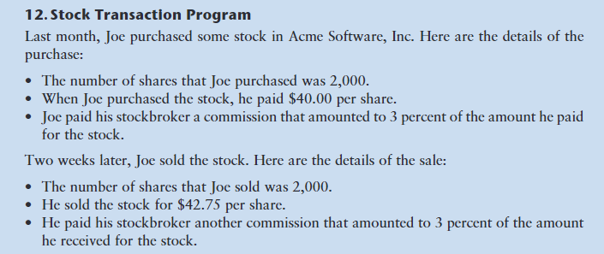

Write a python program called **stocks** that will print the following:

* Amount paid for the stock
* Commission paid on the purchase
* Amount the stock sold for
* Commission paid on the sale
* Profit (or loss if negative)
  + amount sold for – (amount paid + commission on purchase + commission on sale)

Do hand calculations so you know what your output results should be.

Use the flowchart below to help sequence your code.

Commit **stocks** to your github repository CS175L

Upload the github link to the dropbox.

Your printed output should look like this:

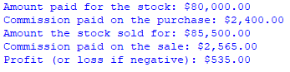

Flowchart

Constant Real COMMISSION_RATE = 0.03

Constant Integer NUM_SHARES = 2000

Constant Real PURCHASE_PRICE = 40.0

Constant Real SELLING_PRICE = 42.75

Declare Real amountPaidForStock

Declare Real purchaseCommission

Declare Real totalPaid

Declare Real stockSoldFor

Declare Real sellingCommission

Declare Real totalReceived

Declare Real profitOrLoss

Set amountPaidForStock = NUM_SHARES * PURCHASE_PRICE

Set purchaseCommission = COMMISSION_RATE * amountPaidForStock

A

Set totalPaid = amountPaidForStock + purchaseCommission

Set stockSoldFor = NUM_SHARES * SELLING_PRICE

Set sellingCommission = COMMISSION_RATE * stockSoldFor

Set profitOrLoss = totalReceived - totalPaid

Set totalReceived = stockSoldFor - sellingCommission

B

Display “Amount paid for stock: $”, amountPaidForStock

End

Display “Profit (or loss if negative): $, profitOrLoss

Display “Commission paid on the sale: $”, sellingCommission

Display “Amount the stock sold for: $”, stockSoldFor

Start

A

B

Display “Commission paid on the purchase: $”, purchaseCommission